

**Faculty of Technology**

**DD University**

A

**Project Report**

On

**E-COMMERCE (BOOK STORE)**

Subject: (CE – 515) Advanced Technologies

B.Tech - CE - Semester 5

Developed by

**Devang P. Bhalala**

**(Roll no: CE007)**

(ID: 18CEUON022)

Guided By

**Associate Prof. Prashant M. Jadav**

Department of Computer Engineering



**CERTIFICATE**

This is to certify that the project entitled “E-Commerce Book Store” is a bonafied report of the work carried out by

**Mr. Devang Prakashbhai Bhalala**

**Roll no.: CE007**

**College ID: 18CEUON022**

of Department of Computer Engineering, semester V, under the guidance and supervision for the subject Advanced Technology. They were involved in Project training during academic year 2020-2021.

Associate Prof. Prashant M. Jadav

Department of Computer Engineering,

Faculty of Technology,

Dharmsinh Desai University, Nadiad

Date: 01/11/2020

Prof. C.K. Bhensdadia

Head, Department of Computer Engineering,

Faculty of Technology,

Dharmsinh Desai University, Nadiad

Date: 01/11/2020

**ACKNOWLEDGEMENT**

The success and final outcome of this project required a lot of guidance and assistance from many people and we are extremely privileged to have got this all along the completion of our project. All that we have done is only due to such supervision and assistance and we would not forget to thank them.

We respect and thank to Associate Prof. Prashant M. Jadav for providing us an opportunity to do the project work in ‘Advanced Technologies’ and giving us all support and guidance which made us complete the project duty. We are extremely thankful to his for providing such a nice support, guidance by taking keen interest in our project, although he had busy schedule managing the lectures.

We would also like to express our special thanks of gratitude to our HOD Prof. C. K. Bhensdadia who gave us the golden opportunity to do this wonderful project on the topic: ‘E-Commerce Book Store’. We would also like to thank him for including such things in curriculum making it more interesting and useful practically.

Finally we would like to thank each and every person who was there around us helping more or less in our project and keeping us motivated to work hard and complete the project. We would also thank them for inspiring us and sharing their ideas and views to make this project a success.

Yours faithfully,

Devang Bhalala

18CEUON022

**TABLE OF CONTENTS**

1 Abstract ……………………………………………………………………..…….…………………….1

2 Introduction ………………………………………………………………………..……………….......2

2.1 Project Details: Brief Introduction ……………………………………….………...................2

2.2 Technology and Tools Used …………………………………...........……………………......2

3 Software Requirement Specifications ………………………..……..…………………………….....4

3.1 Introduction ……………………………………….……..………………….…………………...4

3.2 Overall Description……………………………………………………………………………….5

3.3 External Interface Requirements……………………………………………………………….7

3.2 System Functional Requirements ………………………..………….……………………..…8

3.3 Other Non‐Functional Requirements ……………….……………………….……………....12

4 Design ………………………….……………….……………………………………………………..13

4.1 XML ……………………..…….…………………………………………………..………........13

4.2 DTD ………………………..………………………………………………..…….………..…..17

4.3 XSD……………………….……………………………………………………...…..……...…..18

4.4 DFD ……………………………………………………………………….…………………....19

4.5 E-R Diagram ………….……………………………………………………………..…….......23

5 Implementation Details ……………………………….………………………………..…………....24

5.1 Modules …………………………………..………………………………….…………….......24

5.2 Functional prototypes …………………………………..…….…………………….…….......25

6 Testing ………………………………………………………………………….……………………..29

7 Screen‐shots of the System …………………………………………………………………….......32

8 Conclusion ………………………………………………………………………………….………...44

9 Limitations and Future Extensions of System ………………………………………………….....45

10 Bibliography ……………………………………………………….………………………………...46

**ABSTRACT**

The main objective of the project is to create an online book store that allows users to search and purchase a book online based on title, author and category. The selected books are displayed in a tabular format and the user can order their books online through credit card payment. Using this Website the user can purchase a book online instead of going out to a book store and wasting time.

There are many online book stores like Powell’s, Amazon which were designed using web technologies such as HTML, CSS, JavaScript. I want to develop a similar website using MEAN Stack.

Online Book store is an online web application where the customer can purchase books online. Through a web browser the customers can search for a book by its title or author, later can add to the shopping cart and finally purchase using credit card transaction. The user can login using his account details or new customers can set up an account very quickly. They should give the details of their name, email id and shipping address. The books are divided into many categories based on subject like Data Structures, Data Science, Programming Languages, Block-chain Technology etc.

The Online Book Store Website provides customers with online shopping through a web browser. A customer can, create, sign in to his account, place items into a shopping cart and purchase using his credit card details.

The Administrator will have additional functionalities when compared to the common user. He can add, delete and update the book details, book categories, member information and also confirm a placed order.

This application is developed using MEAN stack technologies, Bootstrap and jQuery. The Modules, Components, Services, Routes, Controllers etc are used to develop the Online Book store.

**INTRODUCTION**

**BRIEF INTRODUCTION**

There are many online book stores like Powell’s, Amazon which were designed using web technologies such as HTML, CSS, JavaScript. I want to develop a similar website using MEAN Stack.

Online Book store is an online web application where the customer can purchase books online. Through a web browser the customers can search for a book by its title or author, later can add to the shopping cart and finally purchase using credit card transaction. The user can login using his account details or new customers can set up an account very quickly. They should give the details of their name, email id and shipping address. The books are divided into many categories based on subject like Data Structures, Data Science, Programming Languages, Block-chain Technology etc.

**TOOLS/ TECHNOLOGIES/ PLATFORMS USED**

TECHNOLOGIES

* HTML5
* CSS3
* JavaScript
* TypeScript
* Bootstrap4
* jQuery
* AJAX
* JSON
* MEAN Stack (MongoDB, ExpressJS, AngularJS, NodeJS)

TOOLS

* + - Visual Studio Code
    - Any Browser which supports above technologies
    - Robo3T

PLATFORM

* Localhost

**Software Requirements Specification**

**INTRODUCTION**

**PURPOSE & MOTIVATION.**

The main objective of the project is to create an online book store that allows users to search and purchase a book based on title, author and categories. The selected books are displayed in a tabular format and the user can order their books online through credit card payment. The Administrator will have additional functionalities when compared to the common user.

The motivation to create this project has many sources

•Interest to develop a good user friendly website with many online transactions using a database.

•To increase my knowledge horizon in technologies like HTML5, CSS3, JavaScript, Bootstrap, jQuery and MEAN stack technologies.

•To gain good experience in MEAN stack.

.

**AUDIANCE DEFINITION**

The expected readers are customers, end users, project manager, developer, tester, coordinators etc.

**REFERENCES**

* Fundamentals of Software Engineering, 2nd Ed , Rajib Mall
* IEEE Standard for writing SRS Document

**OVERALL DESCRIPTION**

**Product Perspective**

* The web application of Book Store should be simple and easy to learn kind of website.
* This website should be user-friendly and responsive type of website.
* It should be platform independent and run on many of the web browsers irrespective to the platform.

**Assumptions**

* The user should know English language.
* The user should be aware of using websites and how to navigate it.
* The user should know about some basic shopping terminologies such as cart, counter, online payment, etc.
* The user must have any online payment option available with them in order to pay online for the product.

**Operating Environment and Dependencies**

* The only need of the operating environment is latest web browser. Any of the latest web browser with access to internet is sufficient enough to use the website.
* Using old versions of browser may lead to some fatal problems using this website.

**Constraints**

* There is not any type of multilingual support for this website.
* This website is limited to HTTP and HTTPS protocols.
* Because of lack of maintainability of the back up for the data, the availability is supposed to get affected.
* This project is for learning purpose and not for professional purpose, so that real time money transaction and real time banking validation may not be implemented.

**Product Functions**

* There are widely two kind of users of the website. 1. Staff from administration department and 2. Normal users, Guests or the customers.
* Normal users/ Guests :
  + User can log into the system.
  + User can navigate through the website.
  + User can search for the product.
  + User can see details of the product.
  + User can purchase the product.
  + User can log out from the system.
* Administration Department :
  + Administrator has authority to make changes in the database of the website by adding or removing the products.
  + S/he can make changes in the category of the products and change their availability.
  + S/he can look into user’s complaint, request or appreciation and reply to them.

**EXTERNEL INTERFACE REQUIREMENT**

**Hardware Interface**

* Any device on which we can run the web browser.
* The device should have enough RAM(2 GB), capable processor, and Internet connection to run the website smoothly.

**Software Interface**

* Operating system using which we can run web browser.
* Any latest web browser which supports modern technologies such as HTML5,CSS.

**Communication Interface**

* Data sender and receiver should be connected via LAN or WAN in order to communicate.
* Administration department may connected through LAN.
* Website server and User can be connected through WAN.

**User Interface**

* Registration and profile management for customers.
* Users can select their interests of products.
* Browsing through the website to see the items that are there in each category of products such as clothes, electronics, books and accessories etc.
* Help desk should be available so that customer can ask question about their query.
* A shopping cart so that customers can shop number of items and checkout with the entire shopping carts. Customers can add or remove items in the cart.

Feedback mechanism, so that customers can give feedback for the product or service which they have purchased. Also facility rating of individual products by relevant customers.

**FUNCTIONAL REQUIREMEMTS**

**R1 Visit the website**

Precondition: Open the URL of the website

**R1.1 Visit the homepage**

Input: URL of homepage or ‘Home’ button press.

Processing: Redirection to homepage

Output: Homepage visible

**R1.2 Visit the Books page**

Input: URL of Books page or ‘Books’ button press.

Processing: Redirection to Books page

Output: Books page visible.

**R1.3 Visit the About us page**

Input: URL of About us page or ‘About us’ button press.

Processing: Redirection to About us page

Output: About Us page visible

Post-condition: null.

**R2 Authentication**

Precondition: User must not be logged in.

**R2.1 Register the user.**

Input: Register Details.

Processing: Validating the details and try to create the user account and log into account.

Output: Successful registration OR Error message.

**R2.2 Log in the user**

Input: Login Details.

Processing: Validating the details and try to log in the user account

Output: Successful log in OR Error message.

Post-condition: User is logged in.

**R3 Manipulate user profile**

Precondition: User must be logged in.

**R3.1 Update the user details.**

Input: Updated user details.

Processing: Try to update the user details.

Output: Successful update OR Error message.

Post-condition: User must remain logged in.

**R3.2 Delete user account.**

Input: Correct old password.

Processing: Try to delete the user account.

Output: Successful deletion the user will be logged out OOR Error message.

Post-condition: User is logged out and account is deleted.

**R3.3 Logout the user**

Input: Click on the ‘Logout’ button.

Processing: Remove the session of user.

Output: User is logged out.

Post-condition: User is logged out.

**R4 Cart Manipulation**

**R4.1 Add item to cart**

Precondition: null

Input: Click on corresponding button.

Processing: Add new item to cart.

Output: Item added.

Precondition: User must be logged in.

**R4.2 Remove Item from Cart**

Input: Click on corresponding button.

Processing: Remove item from cart.

Output: Item removed.

**R4.3 Change the number of quantity.**

Input: Quantity number change of a book.

Processing: Change the quantity of book.

Output: Quantity value changed.

Post-condition: Total bill should be changed in real time.

**R5 Payment Gateway**

Precondition: User must have added at-least one item into the cart.

Input: Payment Details.

Processing: Request source for payment confirmation.

Output: Payment successful OR Error message.

Post-condition:Payment successful or failure depending on Output.

**R6 Administrator Books Manipulation**

Precondition: Admin must be logged in with admin account.

**R6.1 Add he Book.**

Input: New book details.

Processing: Adding new book to database.

Output: New books added.

**R6.2 Update the details of book.**

Input: Updated details of the book.

Processing: Updating the details of the book.

Output: Book details updated.

**R6.3 Get the books details.**

Input: Book’s id number.

Processing: Fetching the book’s details.

Output: The details of the book.

**R6.4 Delete the book item.**

Input: Book’s id number.

Processing: Deletion of the book.

Output: Deletion of book’s message.

Post-condition: Corresponding Output changes must be reflect in normal user’s views.

**NONFUNCTIONAL REQUIREMENTS**

**Security Requirements**

The website must be secure enough from the cyber attacks and must not leak data of users. It must have a secure payment while the transaction of payment.

**Performance Requirements**

The website must not crash or hang while many users are concurrently active on the website. It should run same irrespective to number of user active on the website.

**Error Handling**

The website should handle the errors without any problem caused to the user. The website should improve gradually after knowing such problem and solving the issues.

**Technology Usage**

This website must be build using technologies like HTML5, CSS, JavaScript and Bootstrap. Tools such as NodeJS and AngularJS must be used. MongoDB is required to be used as the Database.

**DESIGN**

**XML/DTD/XSD:**

**XML**

<?xml version="1.0" encoding="UTF-8" ?>

<books>

  <book>

    <book_id>b001</book_id>

    <title>Introduction to Algorithms</title>

    <author>Thomas H. Cormen</author>

    <category>DSA</category>

    <price>1299</price>

    <img>assets/static/books-images/b001.jpg</img>

  </book>

  <book>

    <book_id>b002</book_id>

    <title>Machine Learning using Python</title>

    <author>Dinesh Pradhan</author>

    <category>Data Science</category>

    <price>534</price>

    <img>assets/static/books-images/b002.jpg</img>

  </book>

  <book>

    <book_id>b003</book_id>

    <title>Python Crash Course</title>

    <author>Eric Metthes</author>

    <category>Programming Language</category>

    <price>1269</price>

    <img>assets/static/books-images/b003.jpg</img>

  </book>

  <book>

    <book_id>b004</book_id>

    <title>Blockchain Basics: A Non-Technical Introduction in 25 Steps</title>

    <author>Daniel Drescher</author>

    <category>Blockchain</category>

    <price>720</price>

    <img>assets/static/books-images/b004.jpg</img>

  </book>

  <book>

    <book_id>b005</book_id>

    <title>Art of Computer Programming</title>

    <author>Donald Knuth</author>

    <category>DSA</category>

    <price>2126</price>

    <img>assets/static/books-images/b005.jpg</img>

  </book>

  <book>

    <book_id>b006</book_id>

    <title>Data Science from Scratch</title>

    <author>Steven Cooper</author>

    <category>Data Science</category>

    <price>205</price>

    <img>assets/static/books-images/b006.jpg</img>

  </book>

  <book>

    <book_id>b007</book_id>

    <title>Core Python Programming</title>

    <author>R Nageswara Rao</author>

    <category>Programming Language</category>

    <price>661</price>

    <img>assets/static/books-images/b007.jpg</img>

  </book>

  <book>

    <book_id>b008</book_id>

    <title>The Truth Machine: The Blockchain and the Future of Everything</title>

    <author>Paul Vigna, Michael J. Casey</author>

    <category>Blockchain</category>

    <price>1093</price>

    <img>assets/static/books-images/b008.jpg</img>

  </book>

  <book>

    <book_id>b009</book_id>

    <title>Data Structures and Algorithms Made Easy</title>

    <author>Narasimha Karumanchi</author>

    <category>DSA</category>

    <price>650</price>

    <img>assets/static/books-images/b009.jpg</img>

  </book>

  <book>

    <book_id>b010</book_id>

    <title>Business Analytics: The Science of Data - Driven Decision Making</title>

    <author>U. Dinesh Kumar</author>

    <category>Data Science</category>

    <price>635</price>

    <img>assets/static/books-images/b010.jpg</img>

  </book>

  <book>

    <book_id>b011</book_id>

    <title>R for data science</title>

    <author>Hadley Wickham, Garrett Grolemund</author>

    <category>Programming Language</category>

    <price>2669</price>

    <img>assets/static/books-images/b011.jpg</img>

  </book>

  <book>

    <book_id>b012</book_id>

    <title>Basic Blockchain</title>

    <author>David Shrier</author>

    <category>Blockchain</category>

    <price>391</price>

    <img>assets/static/books-images/b012.jpg</img>

  </book>

  <book>

    <book_id>b013</book_id>

    <title>Data Structures &amp; Algorithms in Java</title>

    <author>Goodrich, Tarassia, Goldwasser</author>

    <category>DSA</category>

    <price>779</price>

    <img>assets/static/books-images/b013.jpg</img>

  </book>

  <book>

    <book_id>b014</book_id>

    <title>Data Science for Business</title>

    <author>Foster Provost</author>

    <category>Data Science</category>

    <price>950</price>

    <img>assets/static/books-images/b014.jpg</img>

  </book>

  <book>

    <book_id>b015</book_id>

    <title>Basic Computation and Programming with C</title>

    <author>Subrata Saha, Subhodip Mukharjee</author>

    <category>Programming Language</category>

    <price>455</price>

    <img>assets/static/books-images/b015.jpg</img>

  </book>

  <book>

    <book_id>b016</book_id>

    <title>Blockchain Revolution</title>

    <author>Don Tapscott, Alex Tapscott</author>

    <category>Blockchain</category>

    <price>1262</price>

    <img>assets/static/books-images/b016.jpg</img>

  </book>

</books>

**DTD:**

<?xml version="1.0" encoding="UTF-8"?>

<!ELEMENT books (book+)>

<!ELEMENT book (book_id, title, author, category, price, img)>

<!ELEMENT book_id (#PCDATA)>

<!ELEMENT title (#PCDATA)>

<!ELEMENT author (#PCDATA)>

<!ELEMENT category (#PCDATA)>

<!ELEMENT price (#PCDATA)>

<!ELEMENT img (#PCDATA)>

**XSD:**

<?xml version="1.0" encoding="UTF-8"?>

<xs:schema xmlns:xs="http://www.w3.org/2001/XMLSchema">

    <xs:complexType name="books">

        <xs:sequence>

            <xs:element name="book" type="book" maxOccurs="20" minOccurs="1"></xs:element>

        </xs:sequence>

    </xs:complexType>

    <xs:complexType name="book">

        <xs:sequence>

            <xs:element name="book_id" type="mystring"></xs:element>

            <xs:element name="title" type="mystring"></xs:element>

            <xs:element name="author" type="mystring"></xs:element>

            <xs:element name="category" type="mystring"></xs:element>

            <xs:element name="price" type="xs:integer"></xs:element>

            <xs:element name="img" type="mystring"></xs:element>

        </xs:sequence>

    </xs:complexType>

    <xs:simpleType name="mystring">

        <xs:restriction base="xs:string">

            <xs:minLength value="3"></xs:minLength>

        </xs:restriction>

    </xs:simpleType>

    <xs:element name="books" type="books"></xs:element>

</xs:schema>

**DATA FLOW DIAGRAM**

**Level 0:**

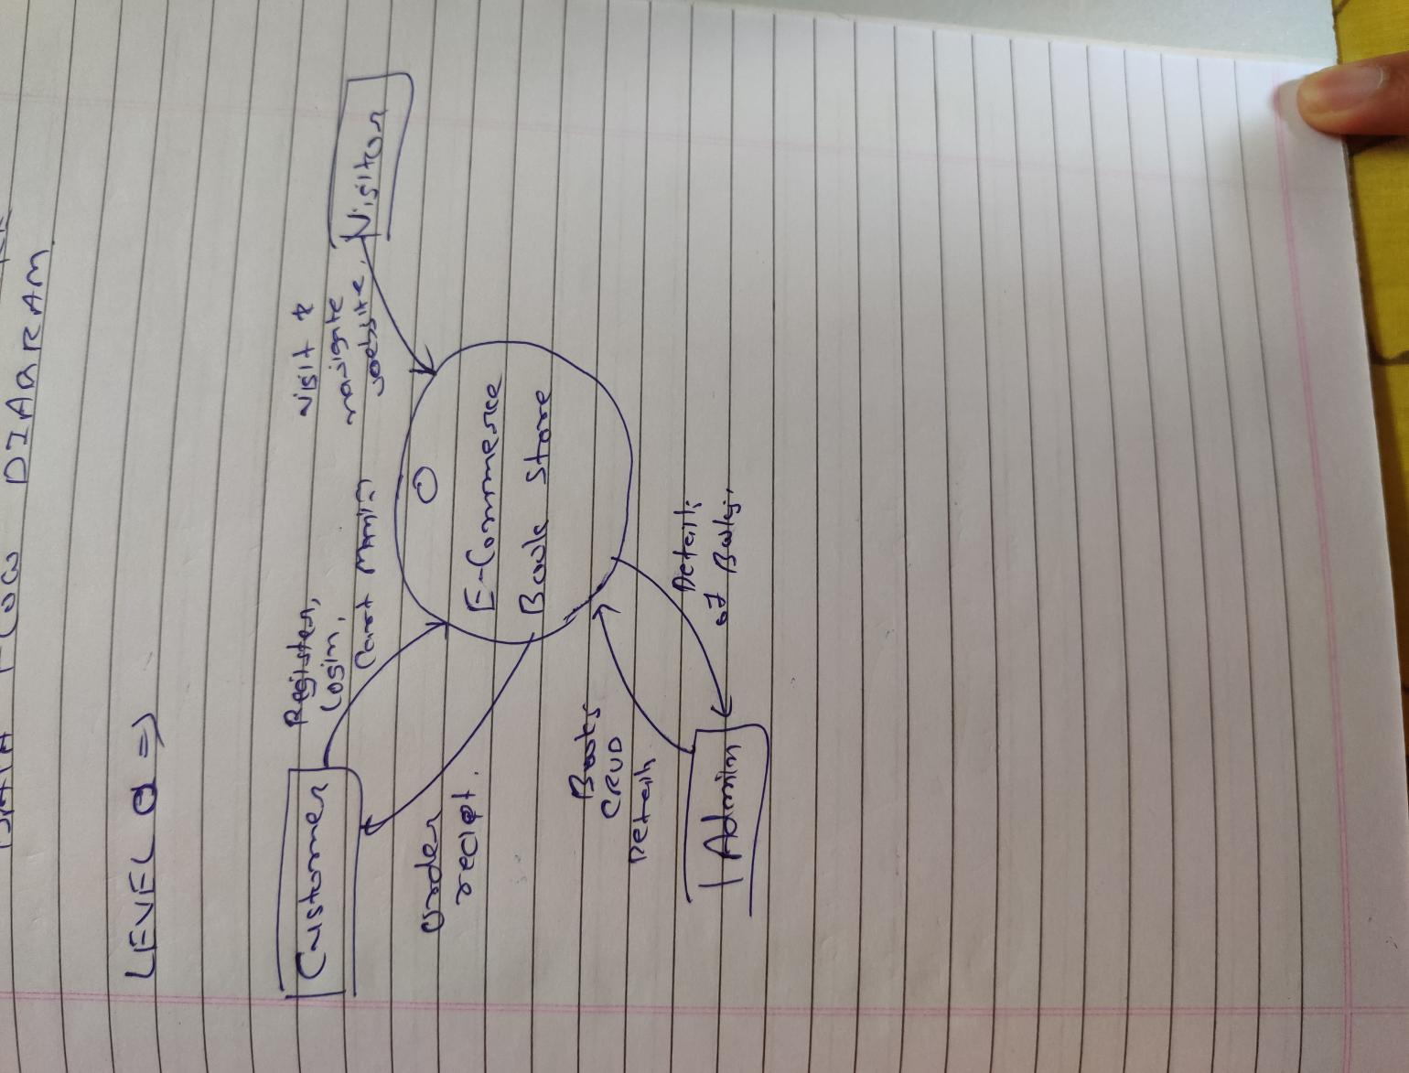

**Level 1:**

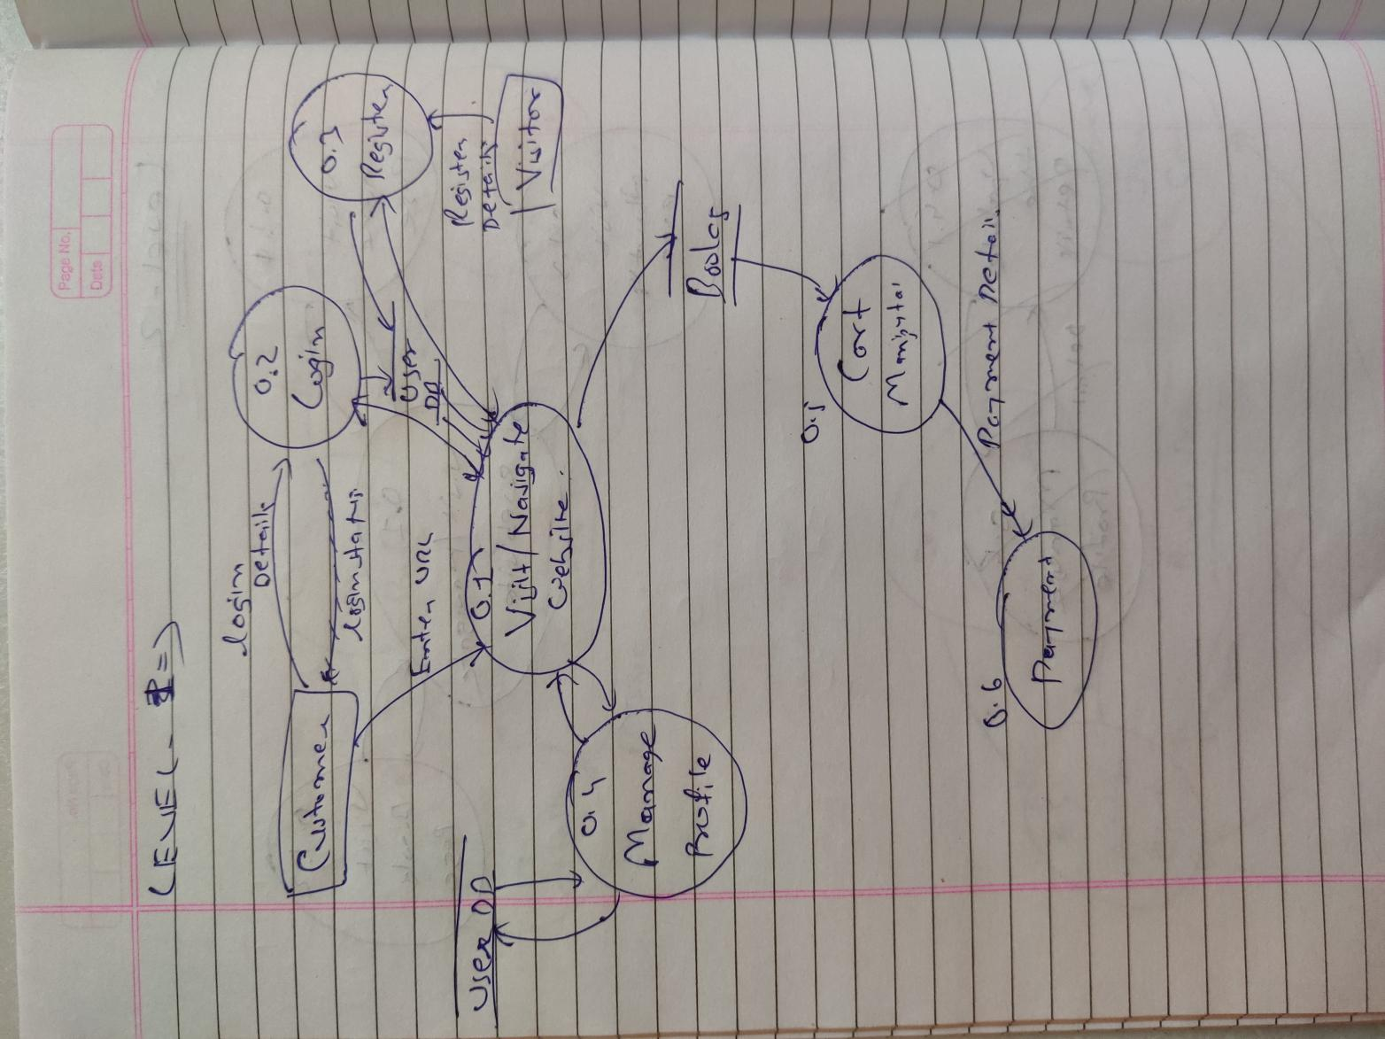

**Level 2:**

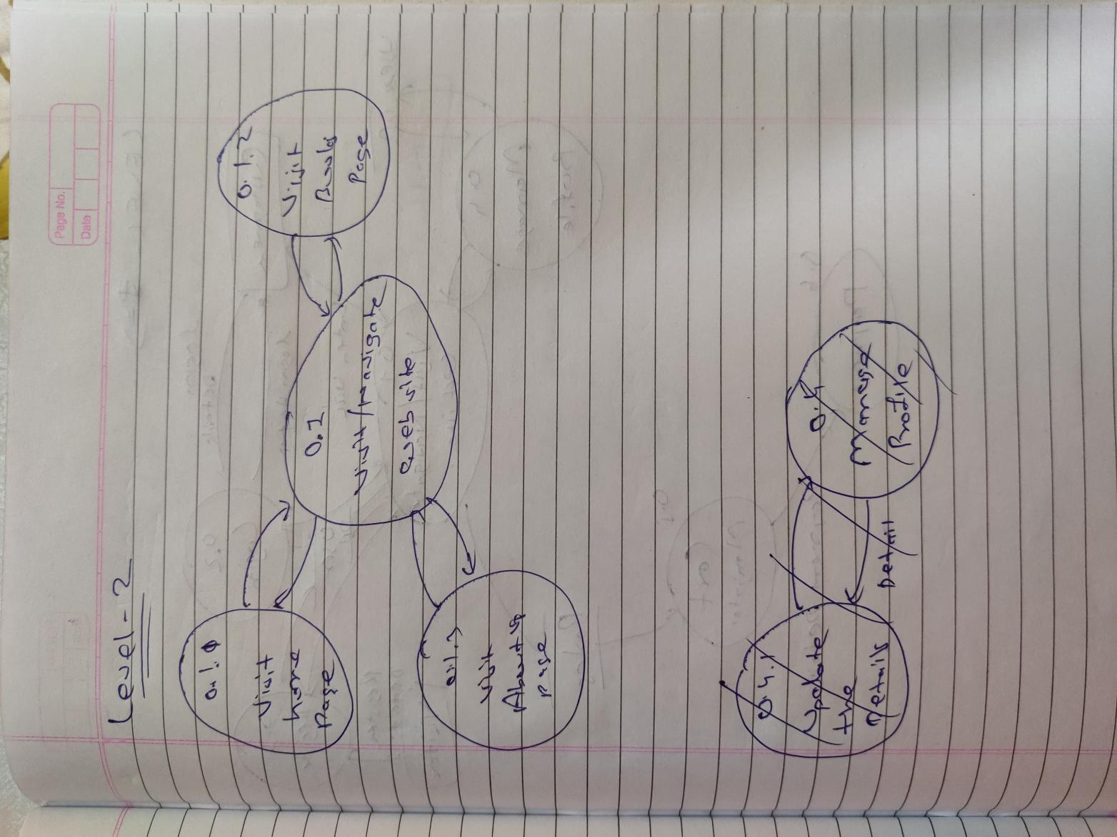

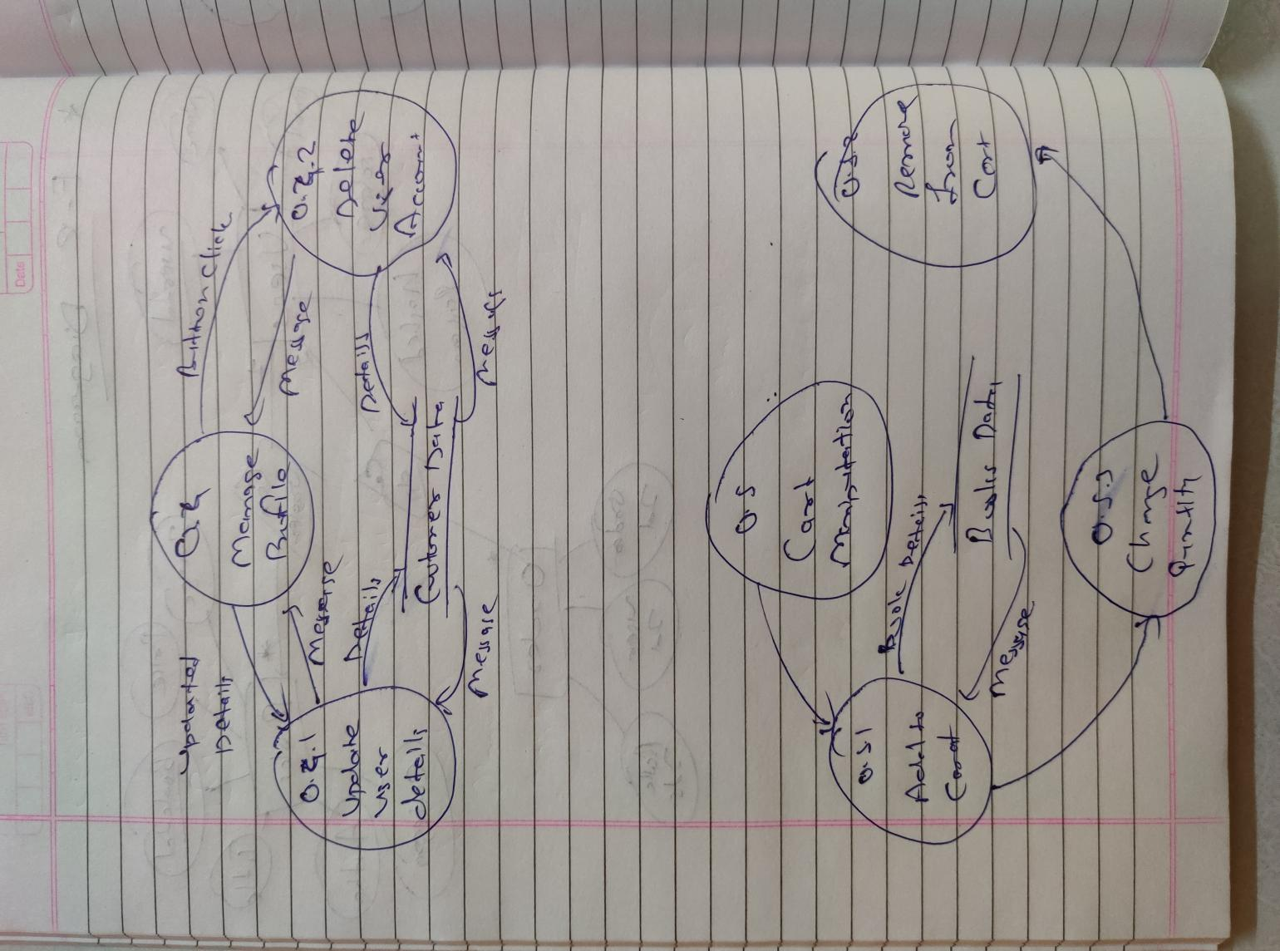

**ER-DIAGRAM:**

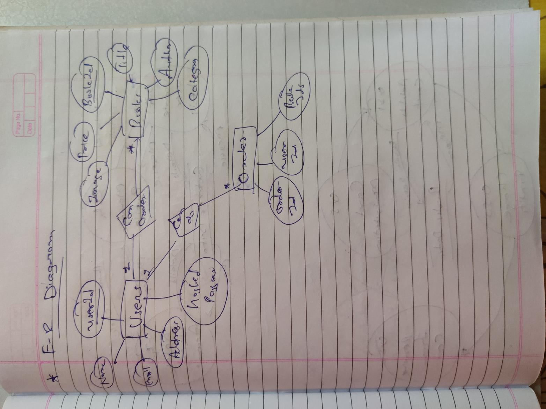

**IMPLEMENTATION DETAILS**

**MODULES DESCRIPTION**

**1 APP MODULE**

This Module contains Basic common components which are used at the global level such as header and footer.

**2 AUTH MODULE**

This module contains components of authentication such as registration, login, delete account an update the details of the user.

**3 BOOKS MODULE**

This module contains the book component which is used to display the books in the table. Filter of the books is also available.

**4 CART MODULE**

This module contains the components which are helpful is cart functions such as adding, removing book and changing the quantity of the book.

**5 CORE MODULE**

This module contains all the services which are needed in the application.

**6 SHARED MODULE**

This module contains those functions which are used the the application.

**FUCTION PROTOTYPE**

**CRUD prototype:**

auth_login(email: string, pwd: string) {

    const loginCred = { email, pwd };

    return this.httpClient.post<userNtoken>(`${this.baseApiUrl}login`, loginCred).pipe(

      switchMap(({ user, token }) => {

        this.setUserAfterFound(user, token);

        return of(this.redierctUrlPostLogin);

      }),

      catchError(err => {

        this.logService.log(err.error.message);

        return throwError(`Login Failed, Please try again.`);

      })

    );

  }

  auth_register(inputUser: any) {

    // Make an API call to save user in DB and update the user subject

    return this.httpClient.post<userNtoken>(`${this.baseApiUrl}register`, inputUser).pipe(

      switchMap(({ user, token }) => { // Happy path

        this.setUserAfterFound(user, token);

        return of(this.redierctUrlPostLogin);

      }),

      catchError(err => {

        this.logService.log(err.error.message);

        return throwError(`Registration Failed, Please try again.`);

      })

    );

    // this.setUser(user);

    // this.logService.log(`Registered ${this.user$} successfully.`);

    // return of(user);

  }

  findJWT() {

    const token = this.tokenStorageService.getToken();

    if (!token) {

      return EMPTY;

    }

    return this.httpClient.get<userNtoken>(`${this.baseApiUrl}findJWT`).pipe(

      switchMap(({ user, token }) => { // Happy path

        this.setUserAfterFound(user, token);

        return of(user);

      }),

      catchError(err => {

        this.logService.log(err.error.message);

        return throwError(`Login Failed, Please Contact to admin department.`);

      })

    );

  }

  private setUserAfterFound(user: User, token: string) {

    this.setUser(user);

    this.tokenStorageService.setToken(token);

    this.logService.log('User found : ', user);

  }

  auth_logout() {

    // Remove User from subject.

    this.tokenStorageService.removeToken();

    this.setUser(null);

    this.logService.log('User has been logged out.');

  }

  auth_old_pwd_validate(email: string, oldpwd: string) {

    const oldPwdEmailCred = { email, oldpwd };

    return this.httpClient.post<userNtoken>(`${this.baseApiUrl}old_pwd_vaidate`, oldPwdEmailCred).pipe(

      switchMap(({ user, token }) => {

        this.logService.log(token);

        this.logService.log("in auth_old_pwd_vali of authService and user is :: ", user);

        return of(user);

      }),

      catchError(err => {

        this.logService.log(err.error.message);

        return throwError(`Old Password Verification Failed, Please try again.`);

      })

    );

  }

  auth_update( inputUser: any){

    return this.httpClient.put<userNtoken>(`${this.baseApiUrl}update/${inputUser.email}`, inputUser).pipe(

      switchMap(({ user, token }) => { // Happy path

        this.setUserAfterFound(user, token);

        return of(this.redierctUrlPostLogin);

      }),

      catchError(err => {

        this.logService.log(err.error.message);

        return throwError(`Registration Failed, Please try again.`);

      })

    );

  }

  auth_delete( email: String ){

    return this.httpClient.delete<userNtoken>(`${this.baseApiUrl}delete/${email}`).pipe(

      switchMap(({ user, token }) => { // Happy path

        return of(user);

      }),

      catchError(err => {

        this.logService.log(err.error.message);

        return throwError(`Registration Failed, Please try again.`);

      })

    );

  }

  auth_get_user( email: string ){

    const email_str = email;

    this.logService.log(`Sending request : ${this.baseApiUrl}getuser/${email}`);

    return this.httpClient.get<any>(`${this.baseApiUrl}getuser/${email}`);

  }

**TESTING**

**TESTING USING KARMA.CONF.JS AND JASMIN**

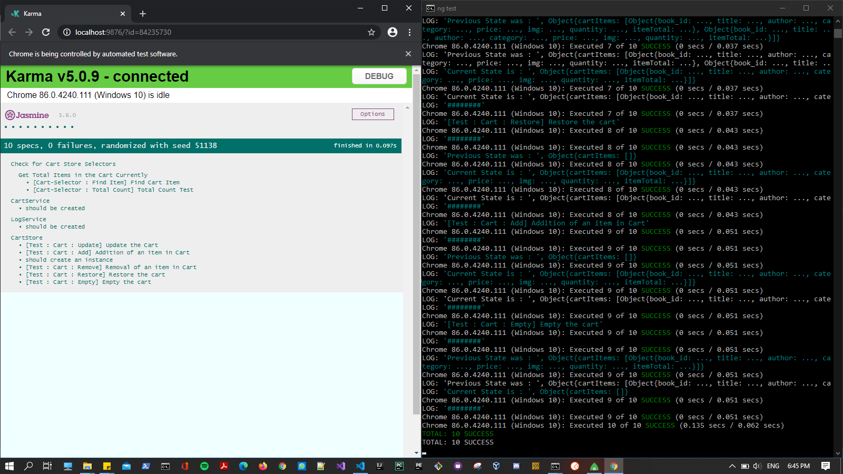

**Error Messages for Invalid Details.**

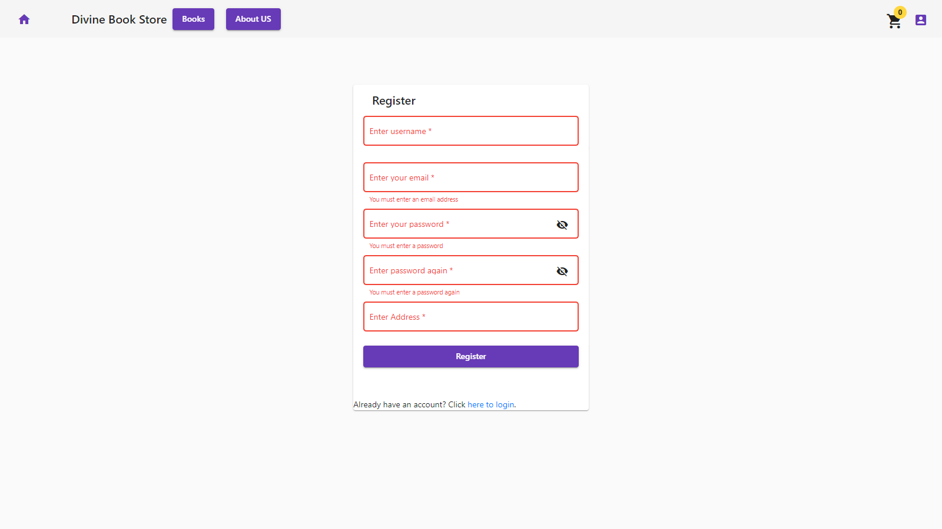

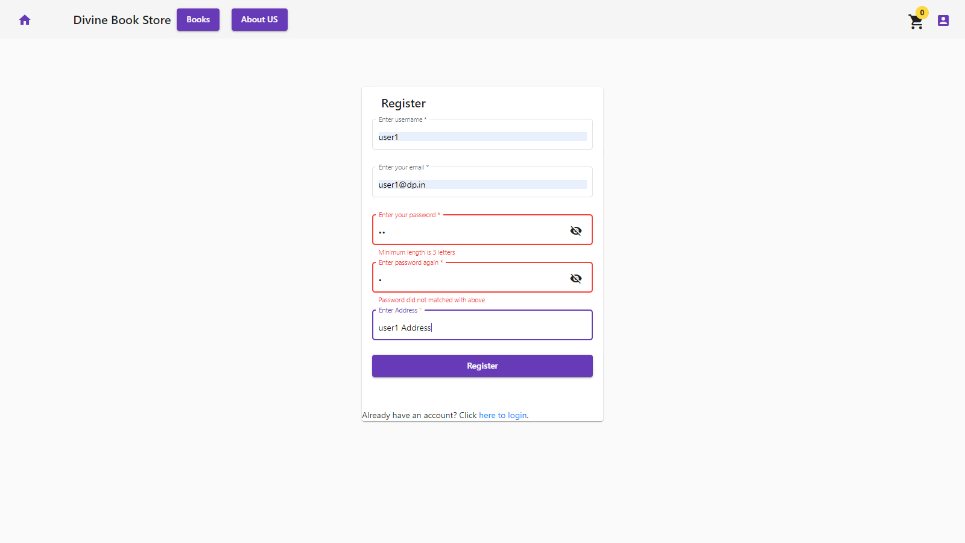

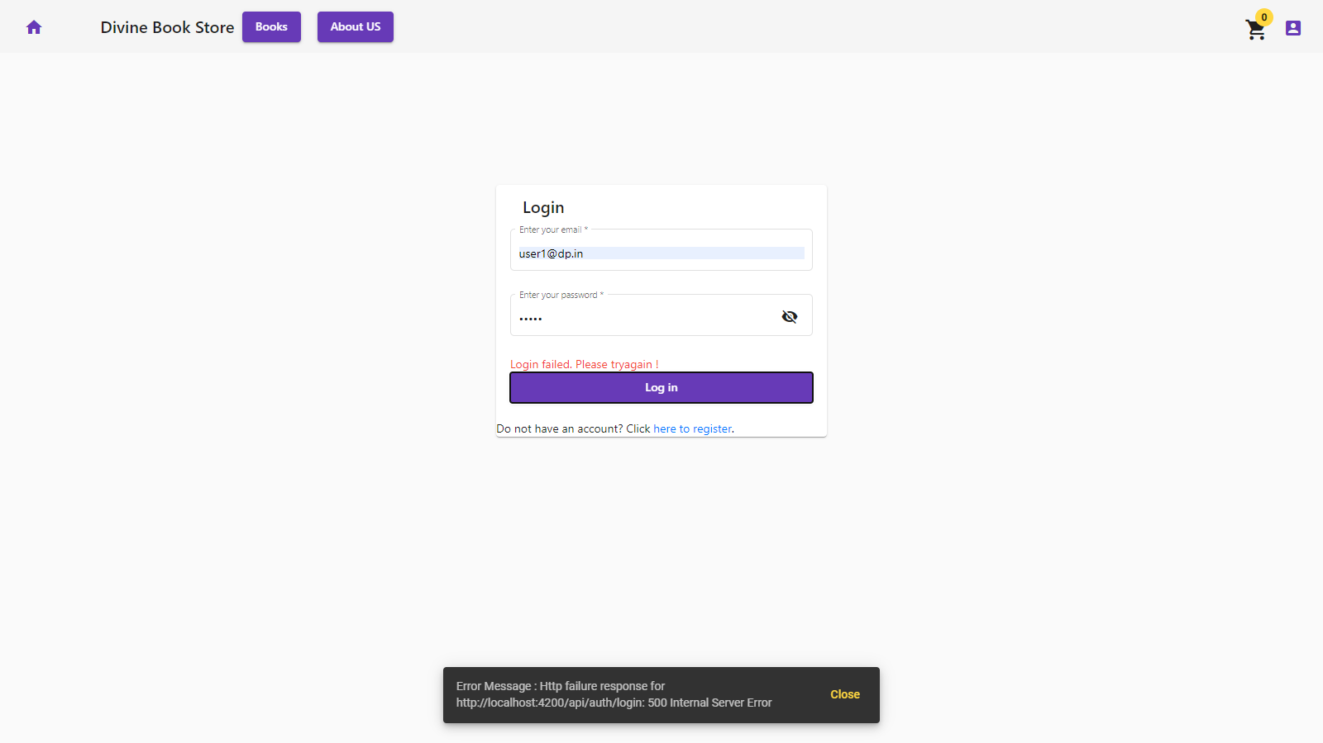

**SCREENSHOTS**

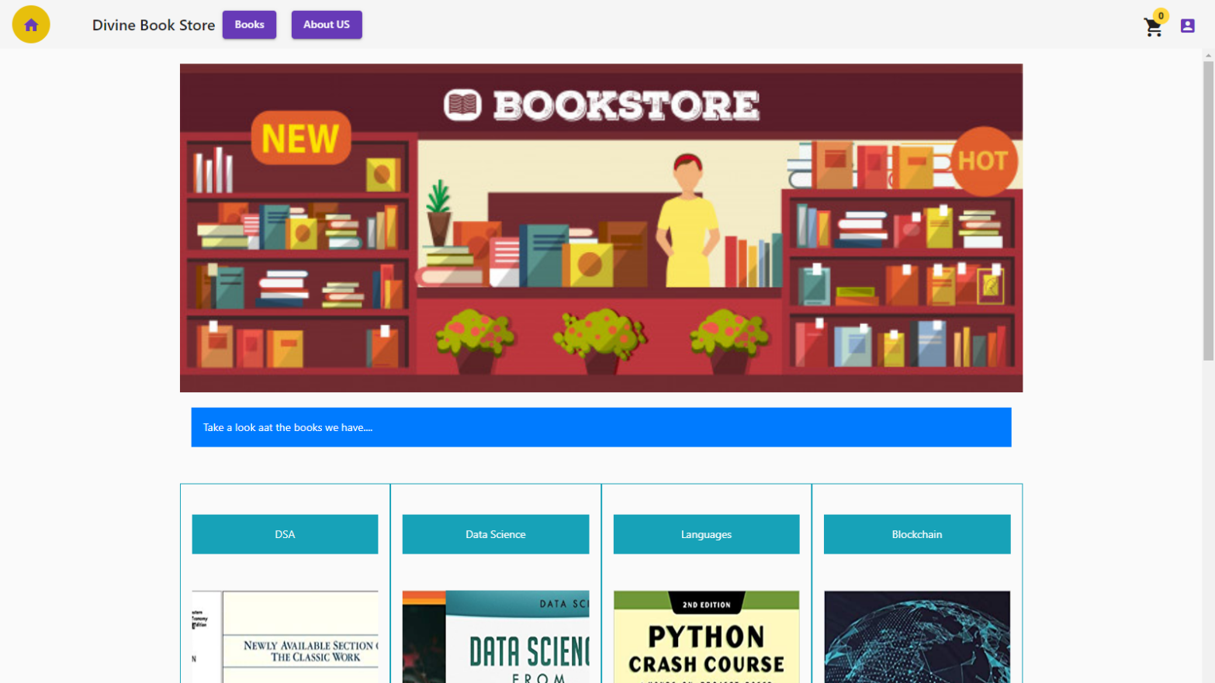

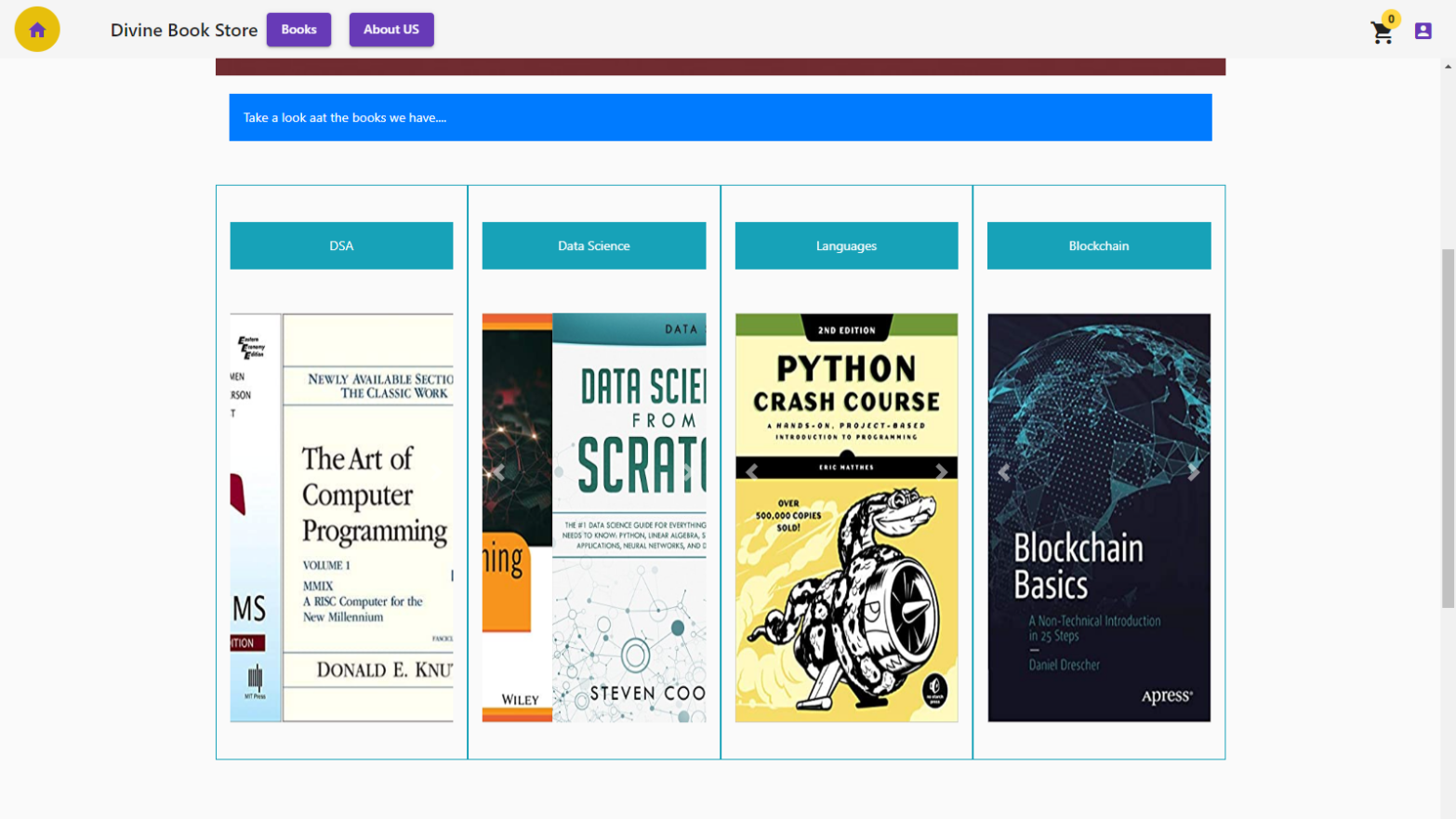

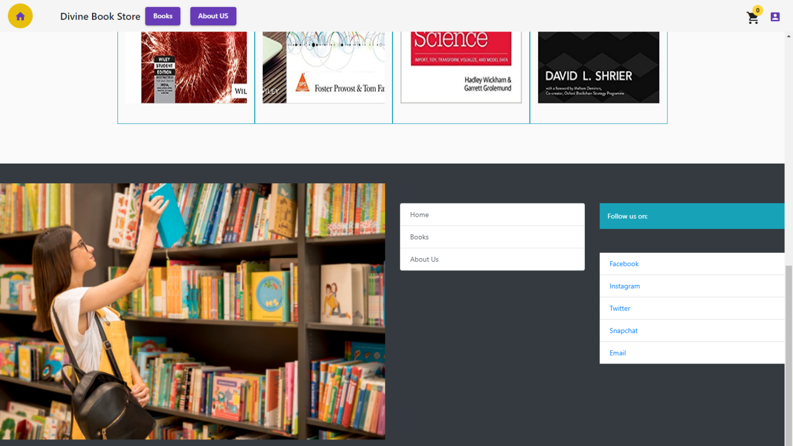

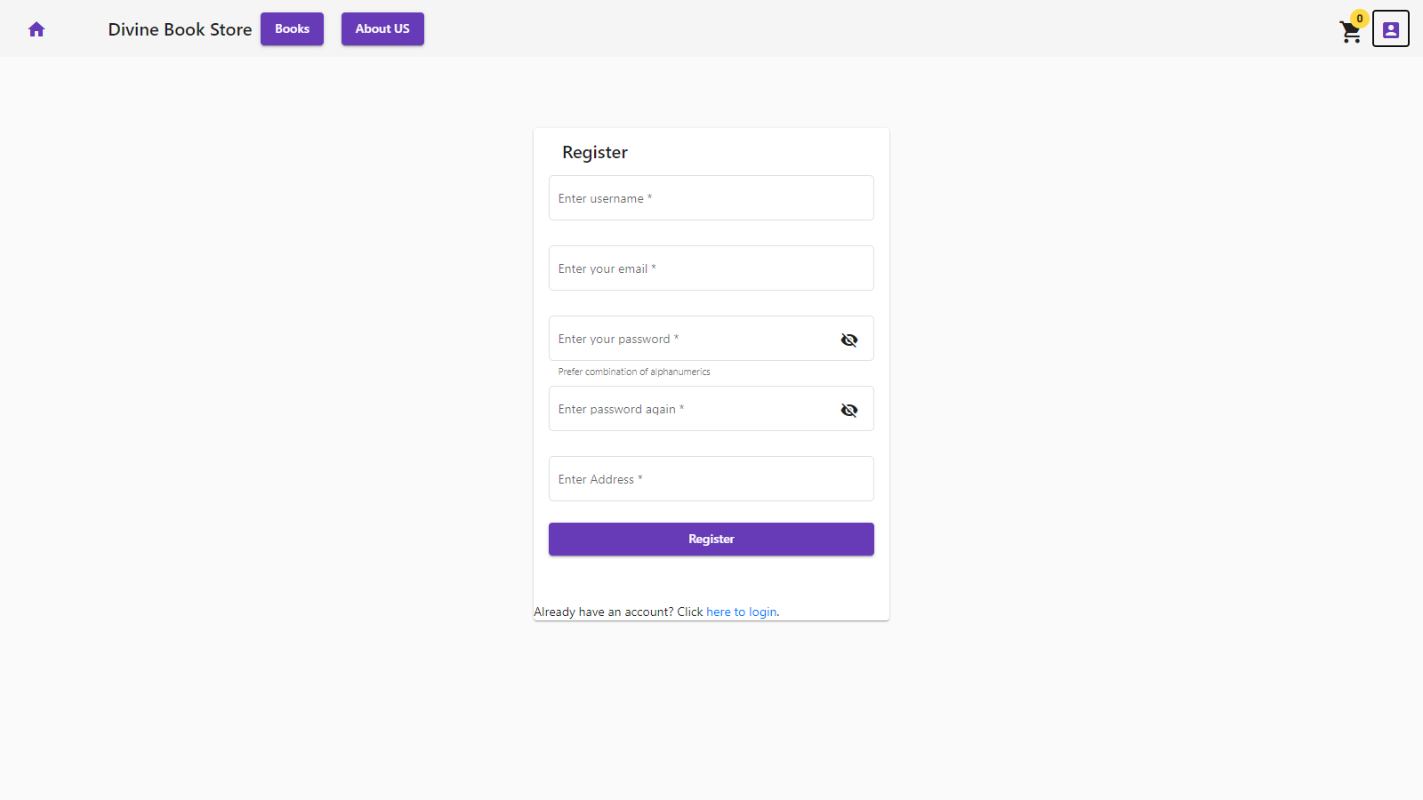

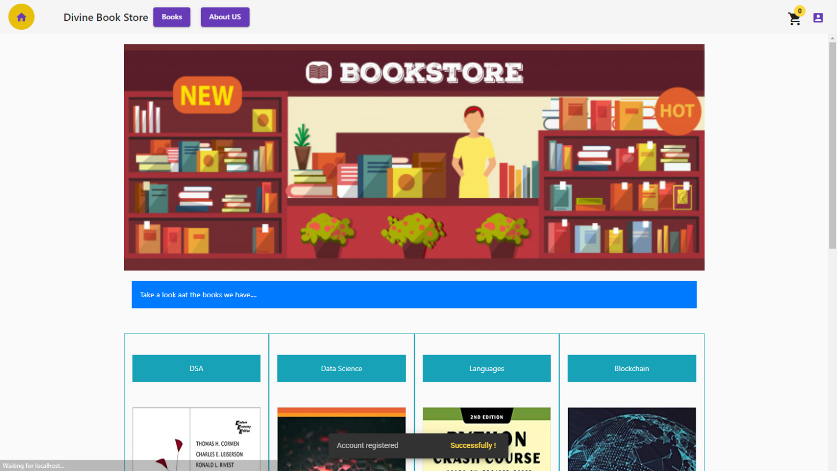

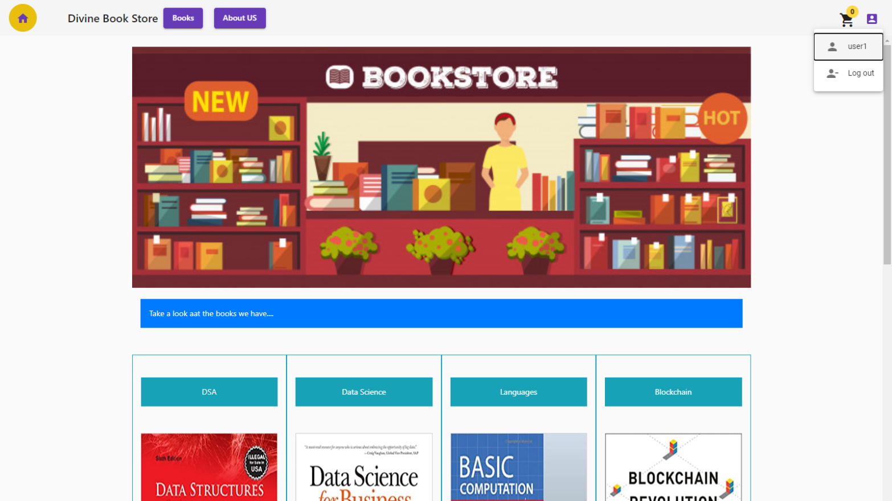

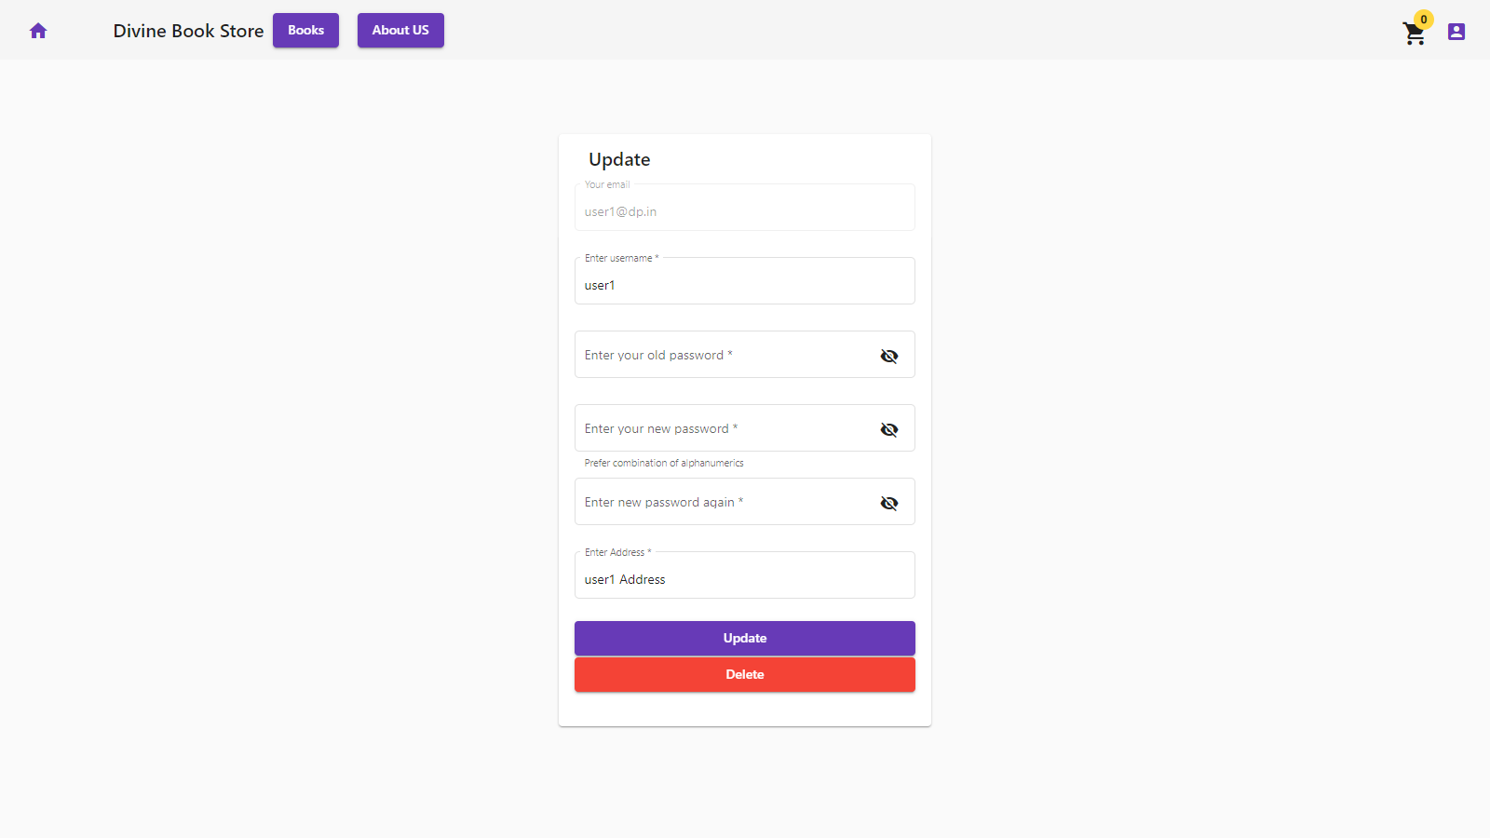

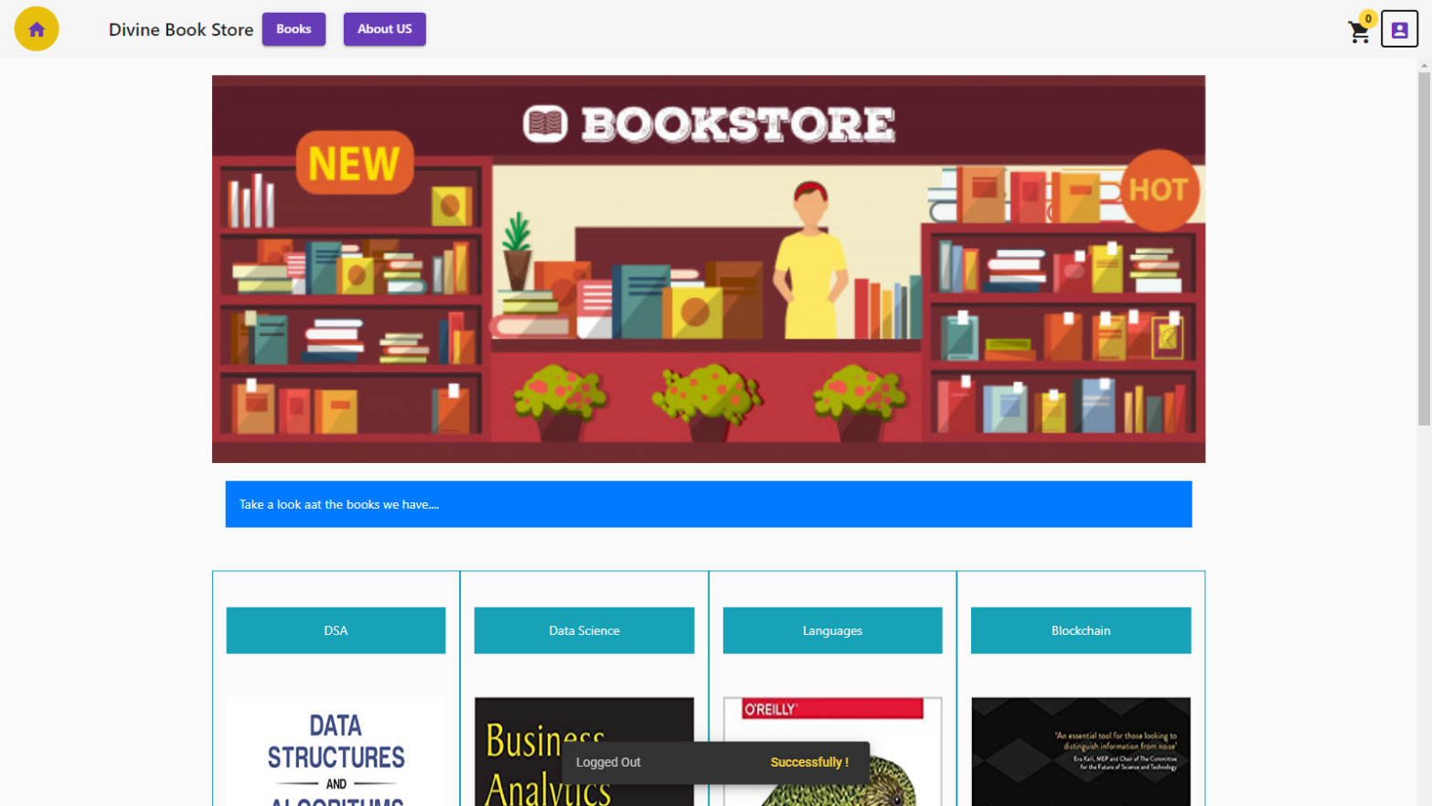

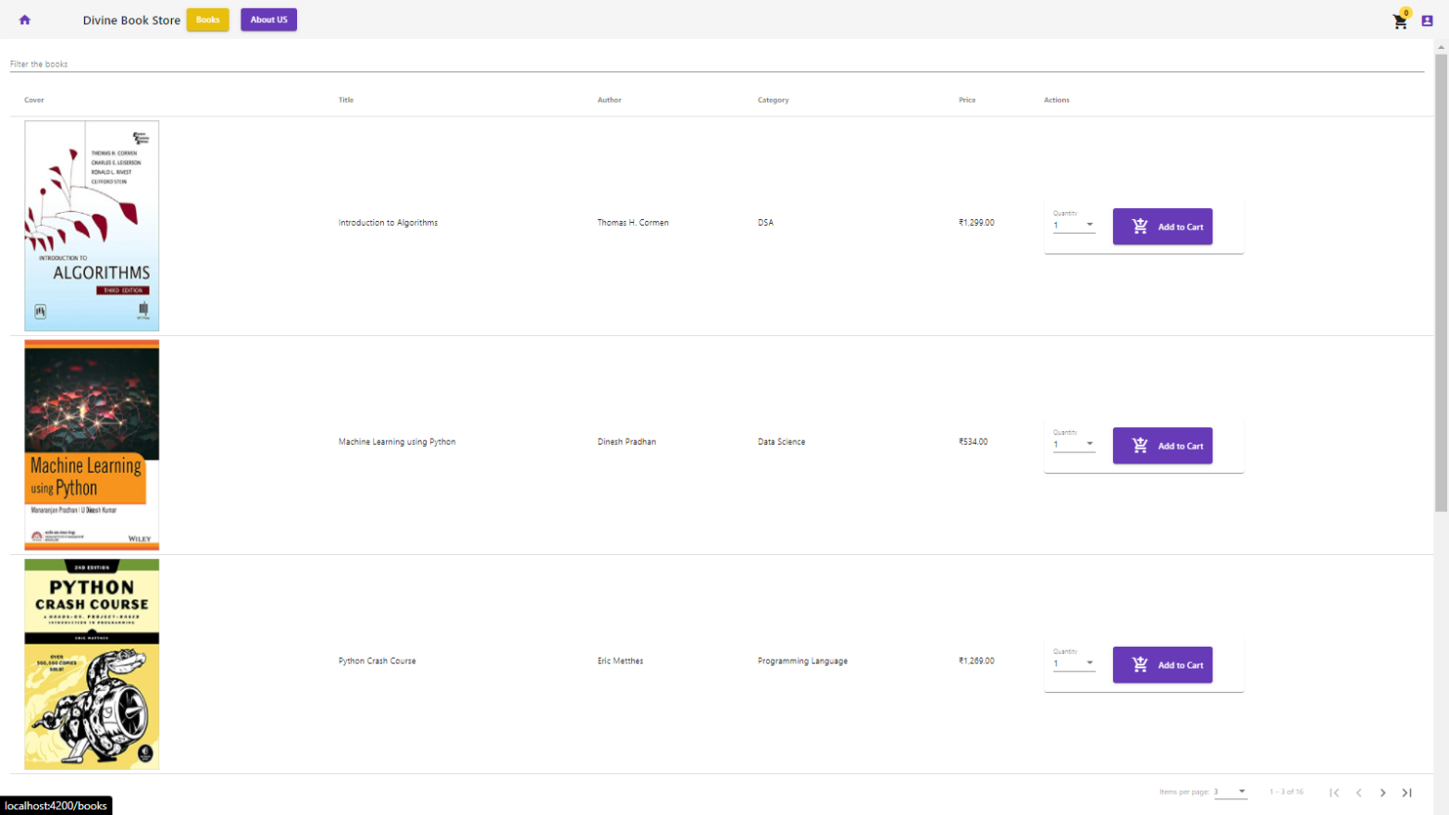

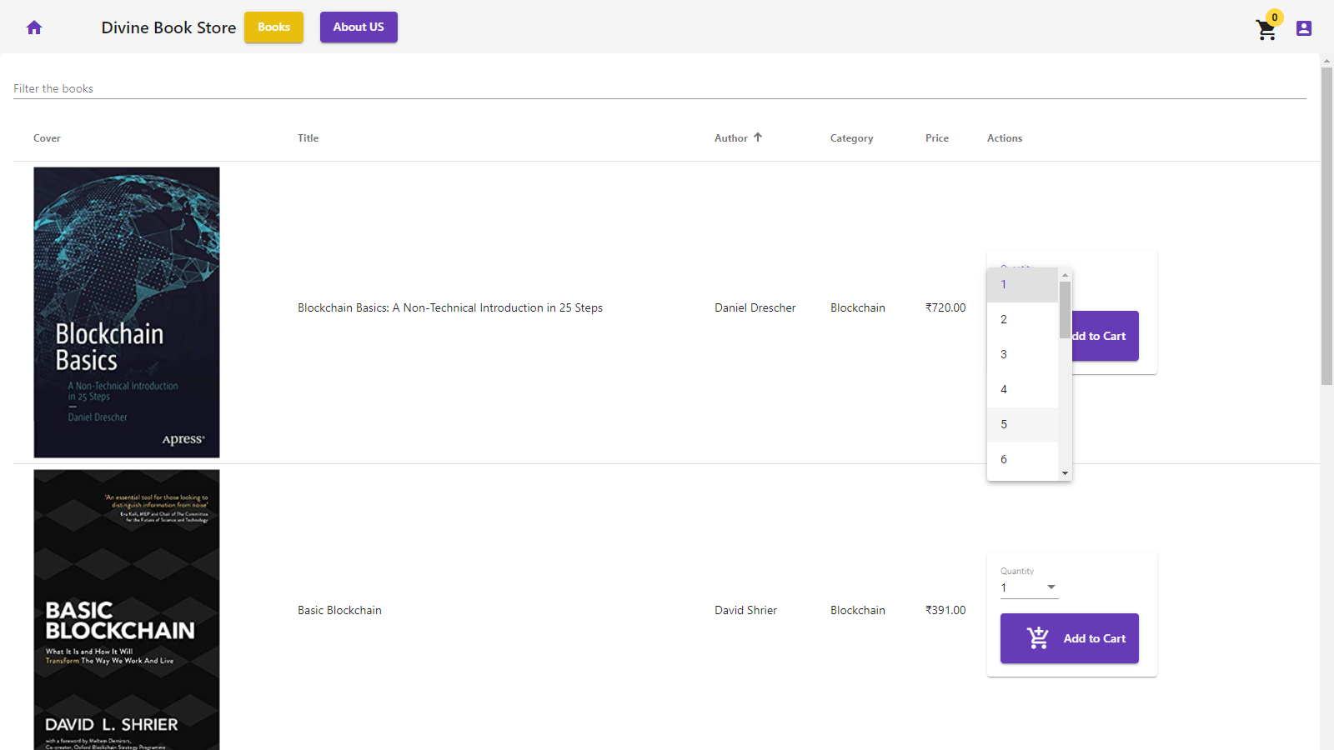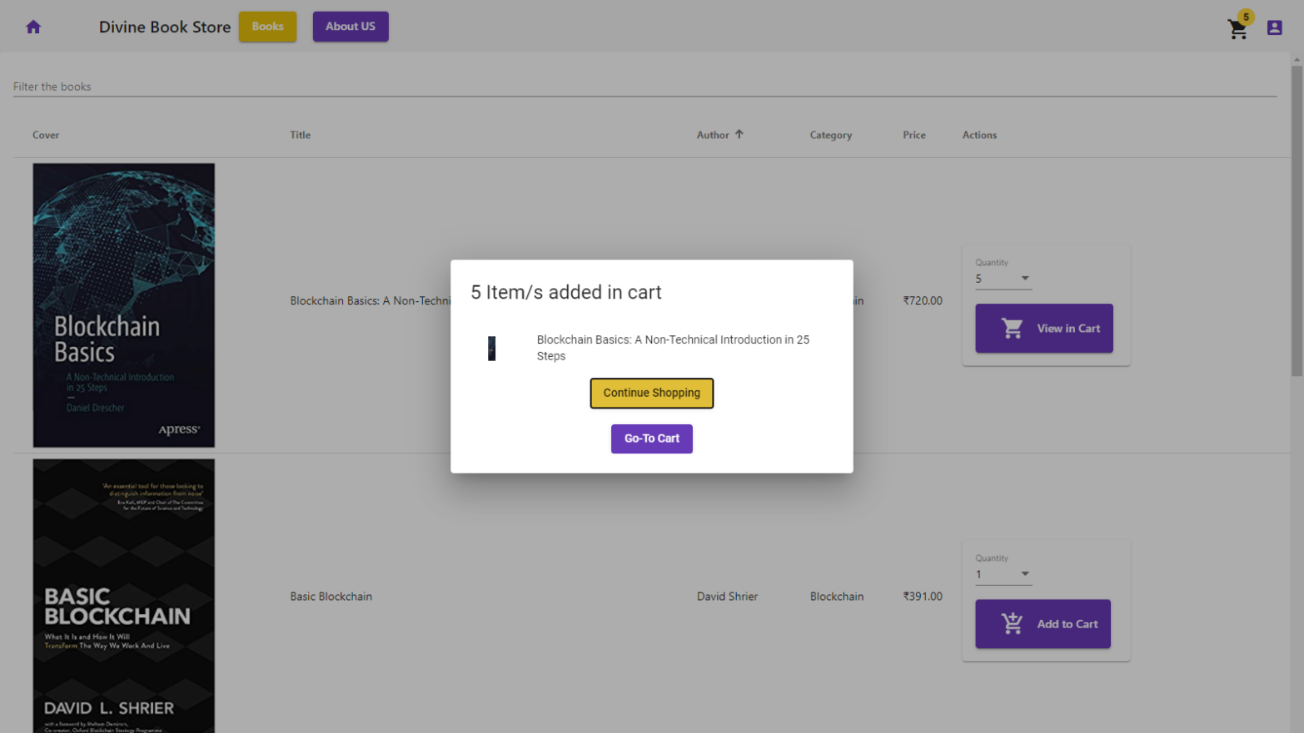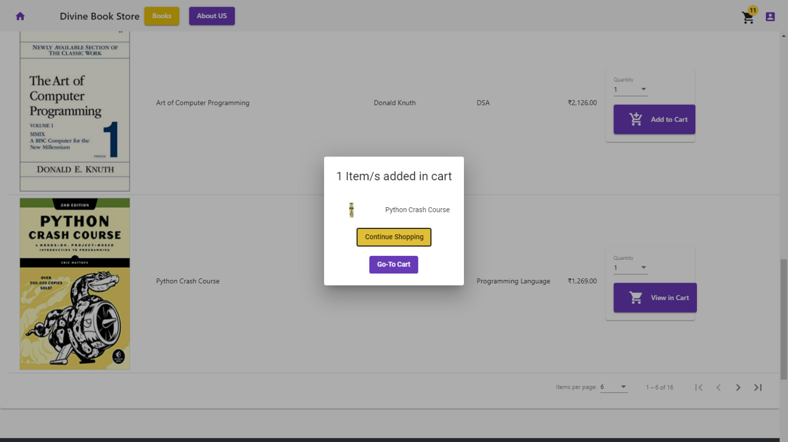

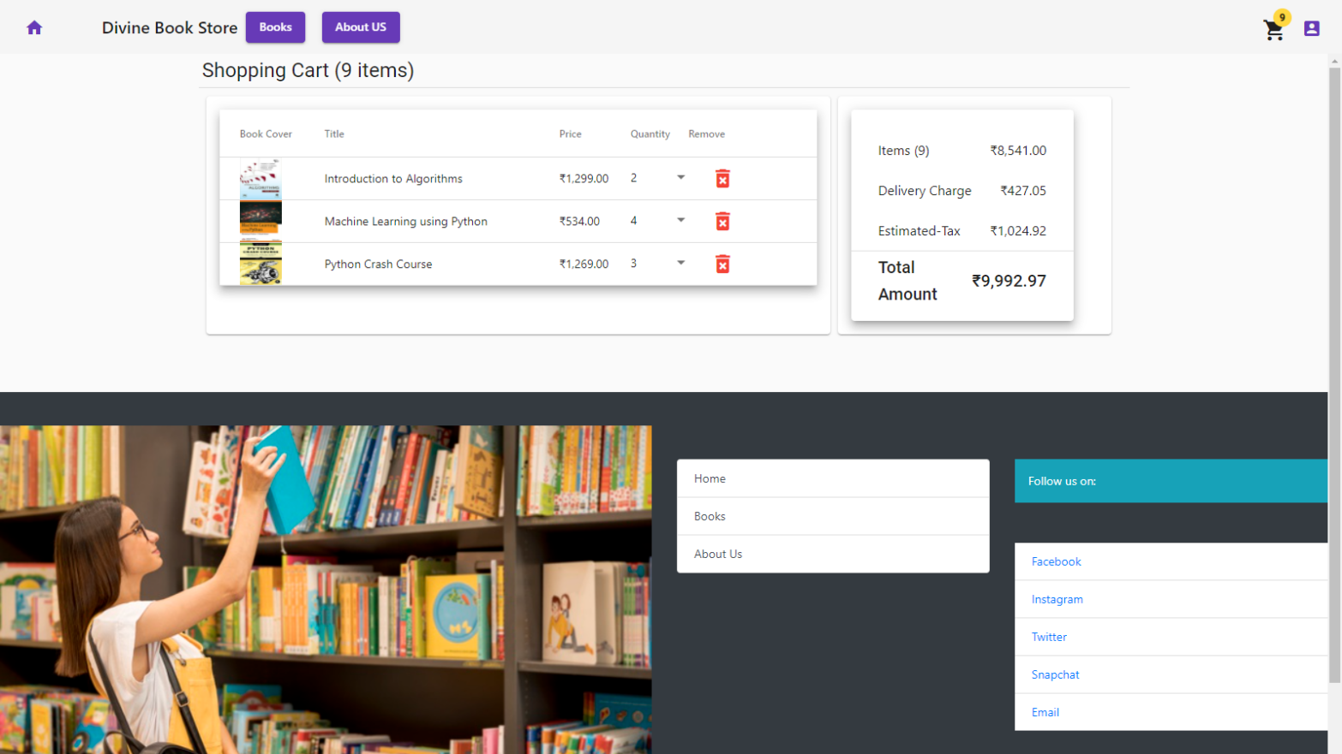

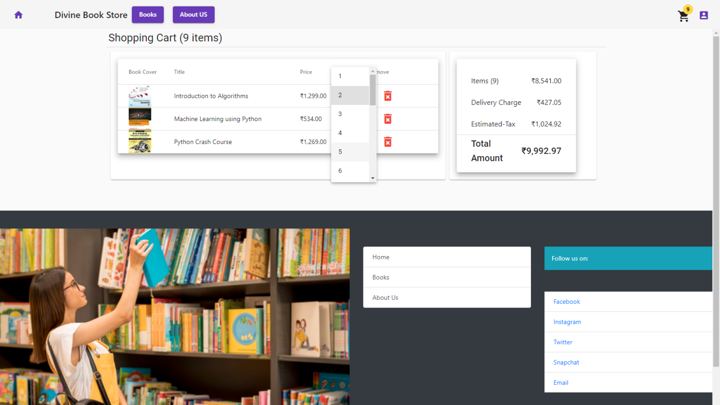

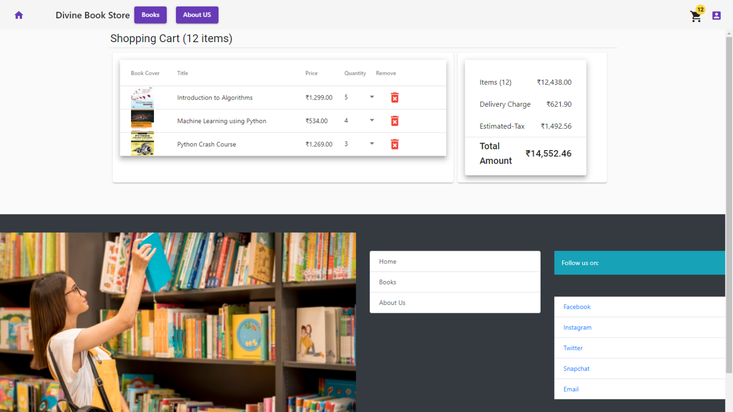

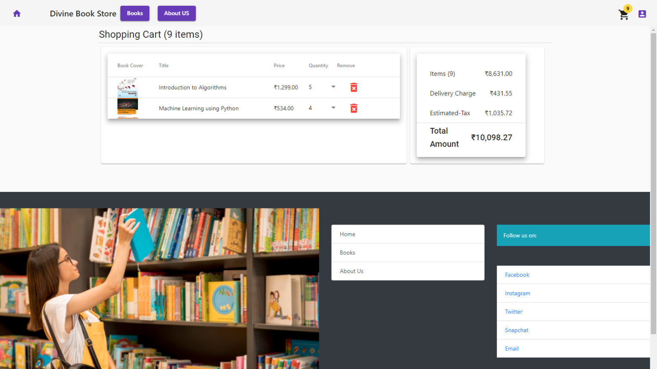

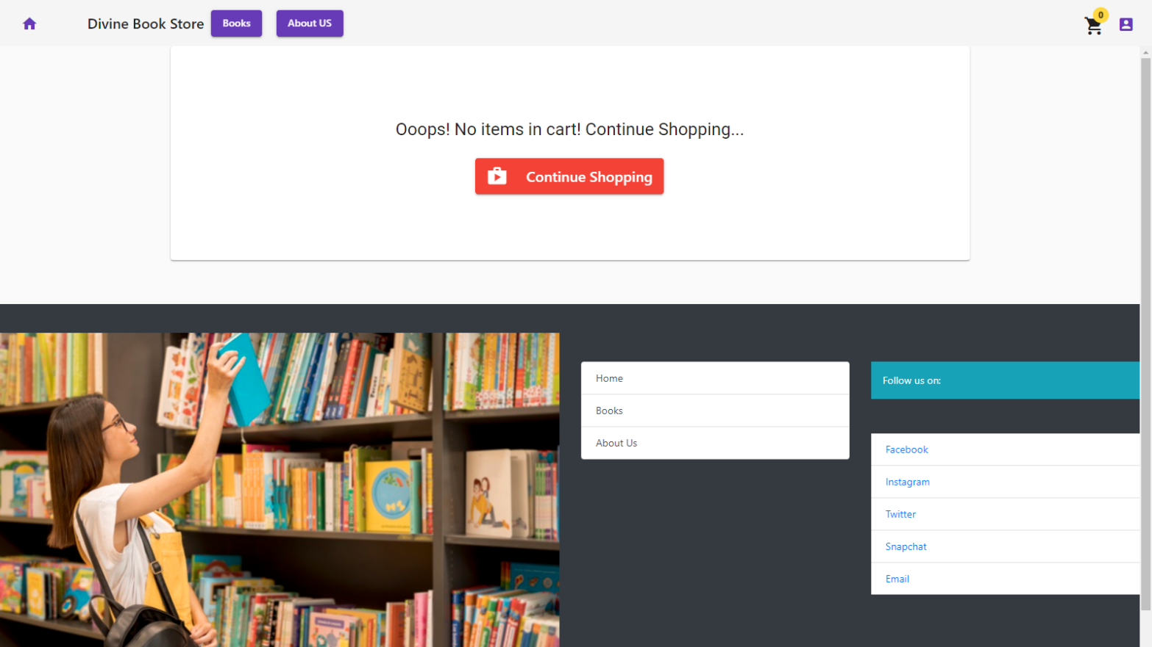

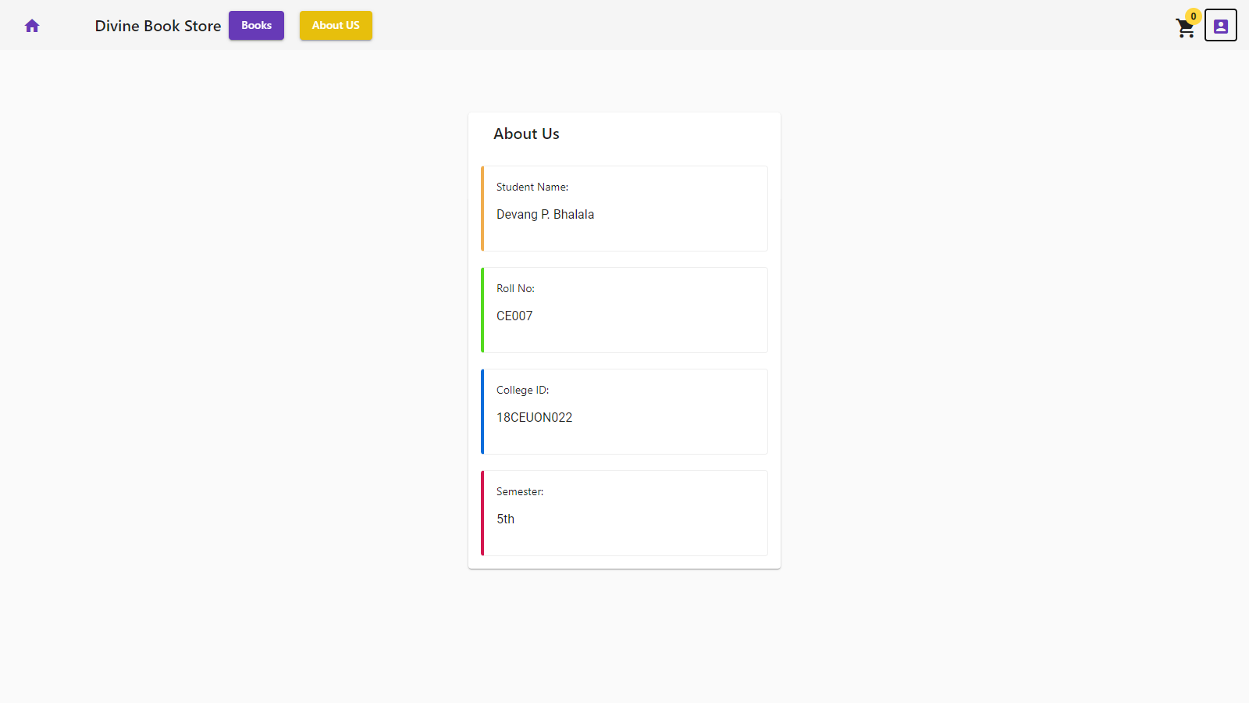

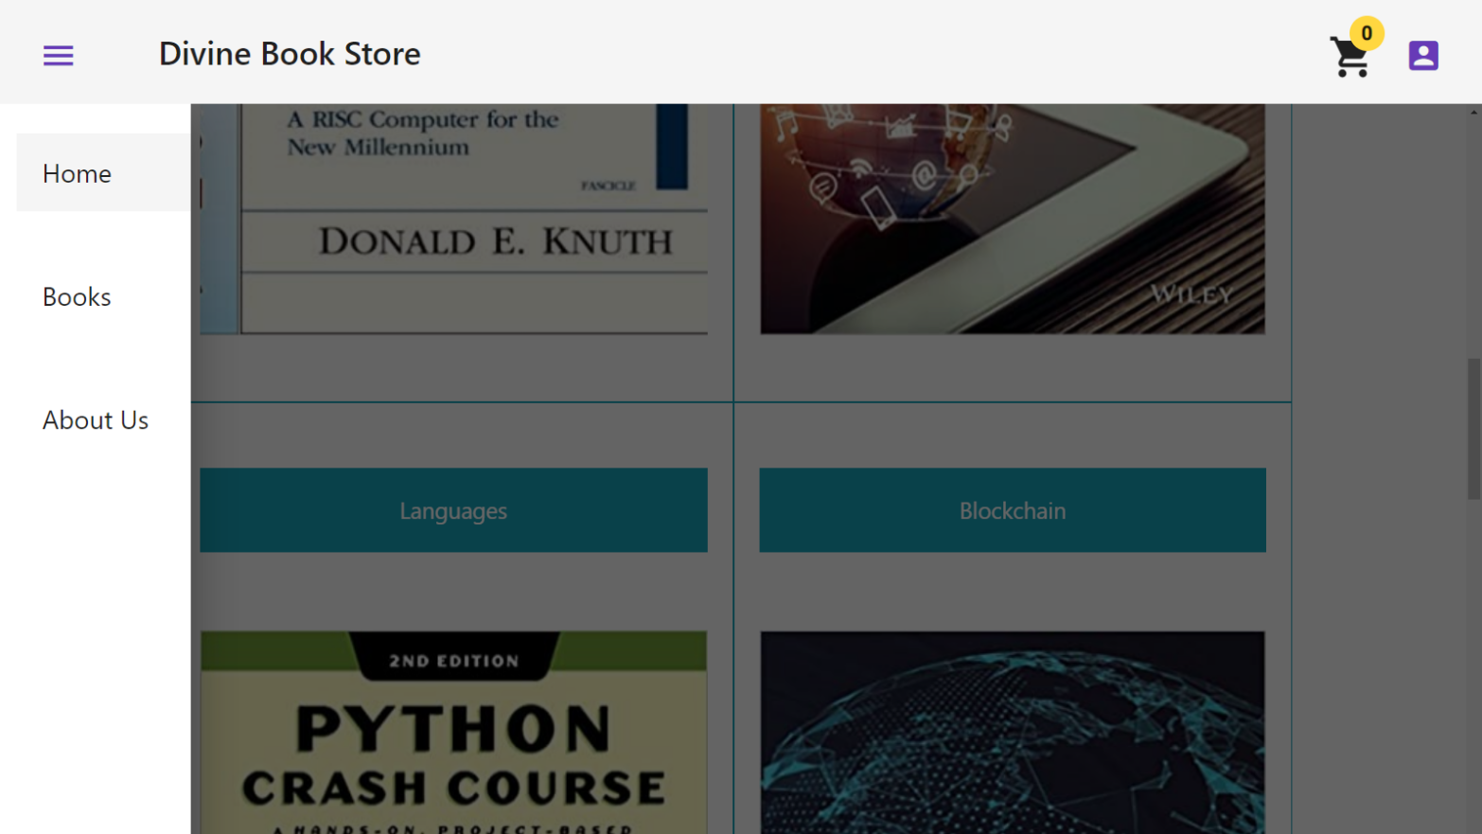

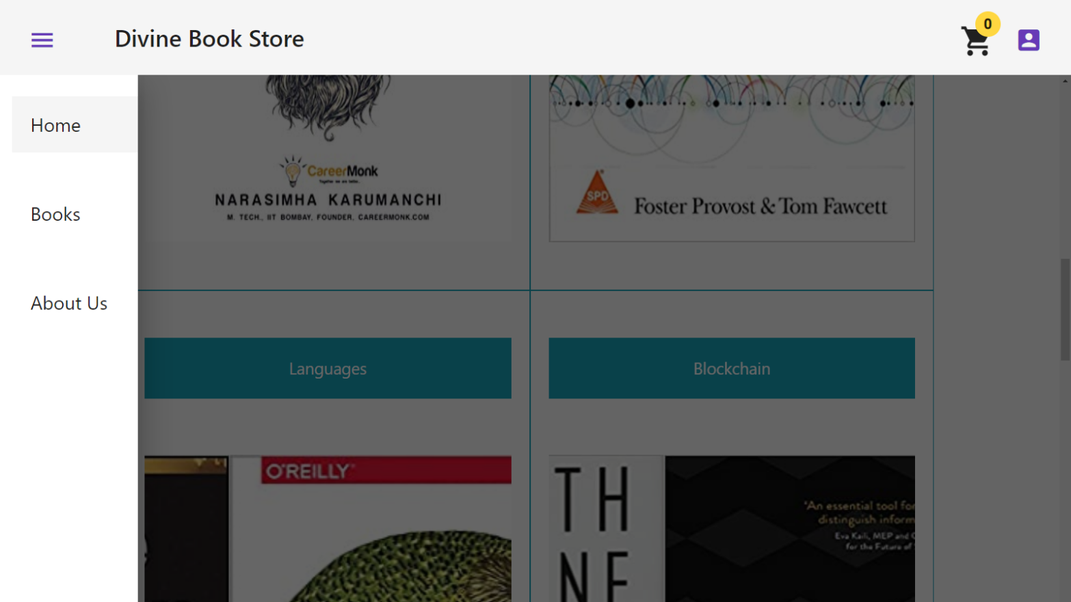

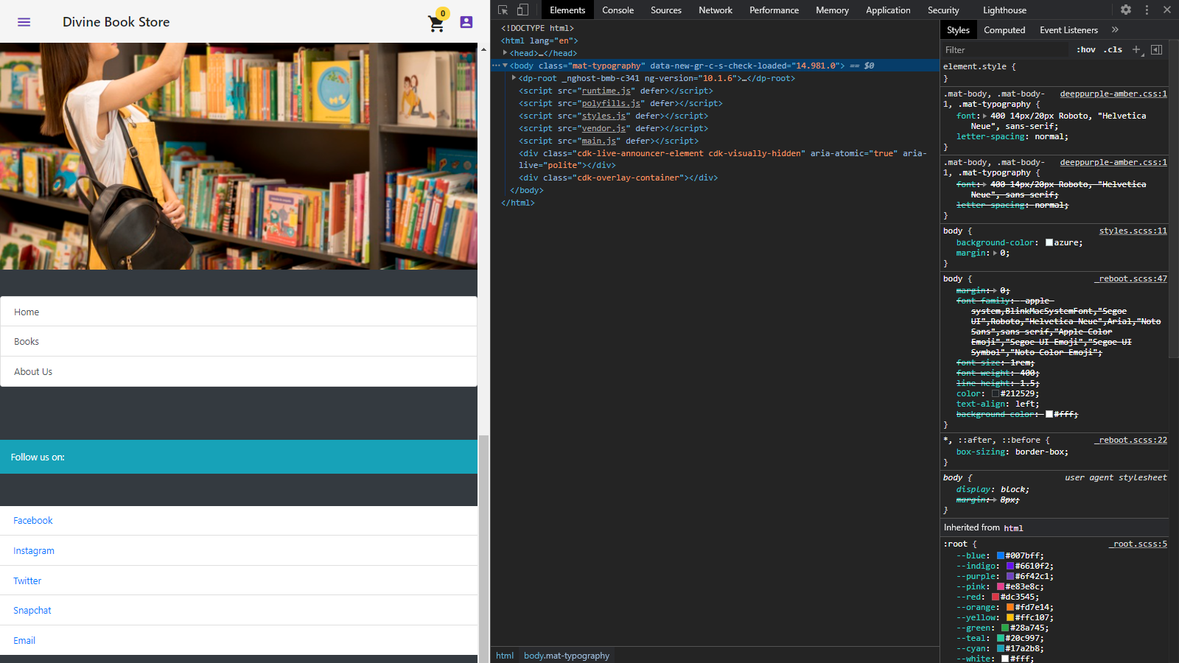

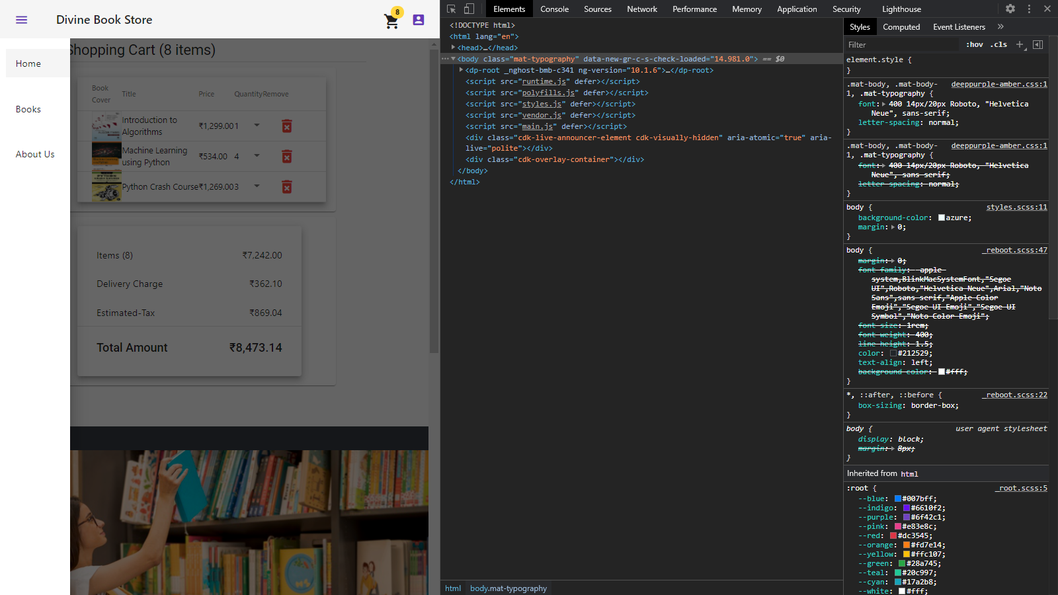

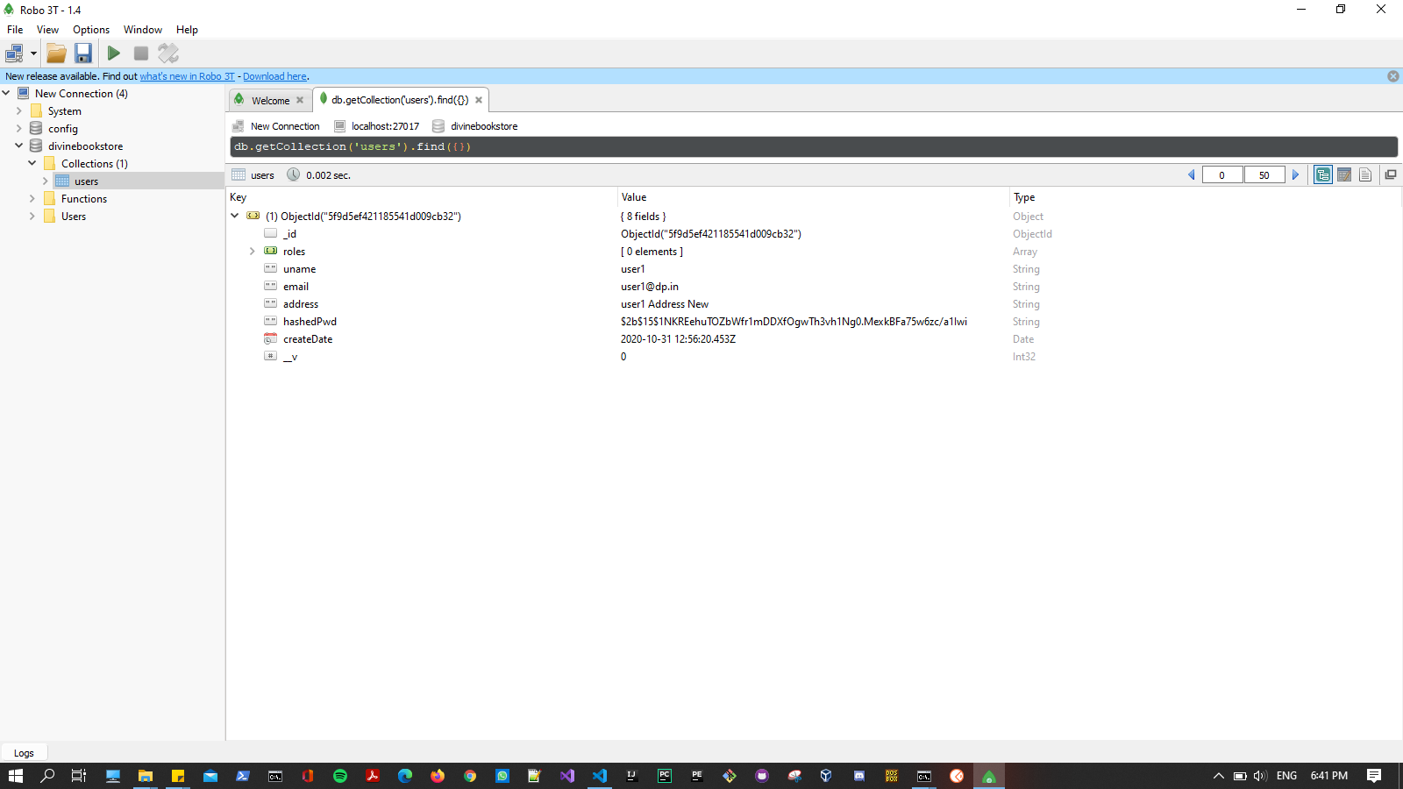

**CONCLUSION**

By this date, I have learned how to work with MEAN stack technologies, Bootstrap and jQuery. Unfortunately, in this project I could not implement all the functionalities but 70 percent of them are implemented. Admin functionalities are remained to implement.

**LIMITATION AND FUTURE EXTENSION**

**LIMIATION**

* This project is not hosted for public. It is on the localhost only.
* Payment gateway is not implemented.

**NOT IMPLEMENTED FUNTIONS**

* Admin Operations
* Payment Gateway

**FUTURE EXTENSION**

* Implementing Admin Operation
* Implement Payment Gateway
* Compare the items
* Feedback system.

**BIBLIOGRAPHY**

**Useful Websites:**

* <https://www.w3schools.com/>
* <https://www.tutorialspoint.com/index.htm>
* <https://angular.io/>
* <https://nodejs.org/en/docs/guides/>
* <https://www.mongodb.com/>